# **15 Reasons Why a BPO for Supply Chain Management Can Transform Your Business**

Business Process Outsourcing (BPO) has revolutionized the global business landscape, enabling companies to improve operational efficiencies, optimize resources, and focus on their core competencies. One key area where BPO offers immense transformative potential is supply chain management.

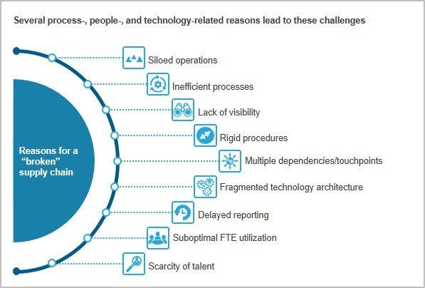

[Source](https://cdn.openpr.com/U/7/U712728343_g.jpg)

Here are the reasons why BPO for supply chain management and supply chain processes can significantly transform your business.

## **1. Cost Efficiency**

One of the principal motivations prompting businesses to resort to Business Process Outsourcing (BPO) for their supply chain management operations centers around the aspect of cost-efficiency. The financial implications associated with establishing and maintaining a robust, in-house supply chain team equipped with the necessary technological tools and systems can prove to be quite substantial, placing a significant strain on a company's resources.

The process of developing an in-house team requires a considerable amount of capital investment, not only in infrastructure but also in the cutting-edge technology necessary to ensure smooth operations. The cost of hiring, training, and retaining a proficient team of human resources to manage these operations also adds to the financial burden. These are primarily fixed costs, which remain constant irrespective of the business volume or market fluctuations, making it harder for businesses to adapt to changes in demand.

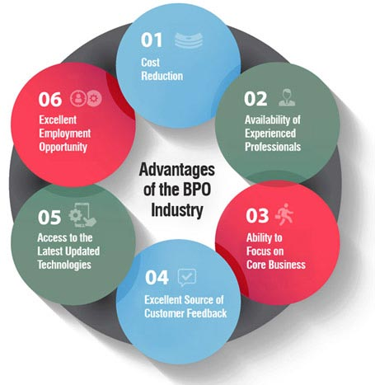

[Source](https://cdn.flatworldsolutions.com/images/articles/bpo-industry-advantages-benefits.jpg)

Businesses can effectively sidestep these heavy capital investments by choosing to outsource these functions to a BPO. The BPO assumes responsibility for the infrastructure, the technological systems, and the skilled personnel, thereby eliminating these considerable expenditures from the company's budget. This financial restructuring shifts these from fixed costs that a company has to bear regardless of its operational scale to variable costs that match the business's needs.

## **2. Access to Expertise and Specialized Knowledge**

Companies specializing in Business Process Outsourcing (BPO) have established a distinctive presence for themselves by concentrating on particular fields of proficiency. This focus empowers them to offer services of exceptional quality in their chosen domains. BPO firms effectively serve as repositories of knowledge, amassing a significant depth of expertise and unique perspectives related to their areas of specialization.

A key component of a BPO's strength lies in its human resources. BPOs house a cadre of highly competent professionals with deep-seated understanding and in-depth domain expertise in supply chain management. These professionals are not just seasoned veterans in their field but are also actively engaged in staying abreast with the industry's constant evolution. They rigorously keep themselves updated on the latest best practices, emerging trends, and technological advancements shaping the supply chain management landscape. This commitment to ongoing learning ensures that the BPOs are always at the forefront of knowledge and expertise.

When businesses outsource their supply chain management to a BPO, they effectively unlock this treasure trove of specialized expertise. The BPO acts as a valuable external resource that supplements its internal capabilities, bringing a fresh perspective and innovative ideas. Through this partnership, businesses can leverage the BPO's extensive knowledge and practical expertise to significantly enhance the effectiveness and efficiency of their supply chain operations.

## **3. Focus on Core Business Functions**

Outsourcing supply chain management allows businesses to concentrate on their core functions. It reduces the burden of managing non-core, complex tasks such as inventory management, logistics, procurement, and other supply chain functions. By doing so, businesses can devote more time and resources to areas directly impacting their bottom lines, such as product development, sales, and marketing.

## **4. Enhanced Risk Management**

By their very nature, supply chains are susceptible to many risks stemming from various sources. These can vary from larger, global disruptions such as economic instability, political upheaval, and natural disasters to more specific issues such as vendor-related complications, logistical challenges, and production inefficiencies. The volatile and interconnected nature of supply chains makes them a critical point of vulnerability for businesses, as disruptions can quickly ripple across the chain, impacting multiple aspects of business operations.

This is where a BPO provider or other third-party service provider steps in. Armed with sophisticated risk management tools and strategies, BPOs work towards significantly reducing the likelihood of unforeseen disruptions that could potentially derail the smooth functioning of the supply chain. They employ advanced analytics, predictive modeling, and scenario planning to proactively identify potential threats, evaluate their possible impact, and formulate effective mitigation strategies.

The risk management strategies used by BPOs are not merely reactive measures to deal with problems as they occur. Instead, they involve comprehensive planning and proactive measures to anticipate potential disruptions, mitigate their impact, and maintain supply chain continuity, even during unforeseen events. They have robust contingency plans and backup strategies in place, meticulously crafted to address a range of risk scenarios.

## **5. Adoption of Advanced Technologies**

The supply chain management domain is undergoing a significant transformation fueled by the rapid advancement and incorporation of innovative technologies. Key developments such as artificial intelligence, data analytics, and blockchain are revolutionizing supply chains' operations, bringing a new level of efficiency, accuracy, and transparency. This technological revolution in supply chain management presents both a challenge and an opportunity for businesses.

Business Process Outsourcing (BPO) companies are often at the vanguard of integrating these groundbreaking technologies into their operations. BPOs are well-versed in harnessing the power of data analytics, artificial intelligence, and blockchain to elevate their services, adapting quickly to changes in the technological landscape.

By choosing to outsource their supply chain management to BPOs, businesses can effectively leverage these advanced technologies to their advantage, without the need for direct investment in procuring and maintaining these systems. This strategy provides them with access to cutting-edge technologies that can enhance their supply chain operations and improve their competitive edge, all while keeping their capital expenditure under control.

In a business era increasingly characterized by digital transformation, staying competitive means embracing new technologies and innovations. Outsourcing to BPOs that are equipped with the latest tech tools can allow businesses to ride the wave of digital transformation, enhancing their supply chain operations and positioning themselves for success in today's dynamic and competitive business environment.

## **6. Increased Scalability**

The unpredictability of market demand is a complex business reality, with a multitude of factors causing it to fluctuate quite dramatically. Seasonal variations, trending consumer preferences, and large-scale global events can all contribute to rapid changes in demand patterns. This inherent variability presents businesses with the dual challenge of swiftly scaling up their operations to meet sudden surges in demand and simultaneously scaling down just as quickly during periods of lower demand.

This is where Business Process Outsourcing (BPO) companies provide an invaluable service. They offer scalable solutions tailored to adapt to these changing market dynamics. BPOs are equipped with the necessary resources and strategies to seamlessly adjust their operations in accordance with the ebb and flow of market demand. Their robust infrastructure and trained manpower provide the flexibility to ramp up operations during times of high demand and, equally, to scale back during quieter periods.

## **7. Improved Customer Satisfaction**

Effective supply chain management is central to ensuring customer satisfaction is pivotal to a business's success. It is the lifeline that guarantees products reach customers' hands in the right quantity, at the right moment, and at the right location. The precision and efficiency of supply chain management can significantly influence a customer's experience and perception of the business.

Business Process Outsourcing (BPO) companies bring to the table robust systems and refined processes to effectively manage these crucial aspects of supply chain operations. Their systems are designed to orchestrate and coordinate every stage of the supply chain, from procurement to production and from warehousing to distribution. Managing these complex processes effectively ensures the timely and accurate delivery of products to customers.

When a BPO company manages your supply chain, they assume responsibility for maintaining optimal inventory levels, ensuring you have just the right amount of product available at all times. This balance helps prevent stockouts and overstock situations, which could harm your business financially and impact customer satisfaction.

BPO firms provide services round the clock, ensuring speedy and efficient execution of tasks. This results in faster order processing, quicker turnaround times, and shorter delivery cycles. It also allows businesses to meet customer demands more efficiently and handle unexpected spikes in demand, leading to improved overall performance.

## **8. Speed and Efficiency**

BPO firms provide services round the clock, ensuring speedy and efficient execution of tasks. This results in faster order processing, quicker turnaround times, and shorter delivery cycles. It also allows businesses to meet customer demands more efficiently and handle unexpected spikes in demand, leading to improved overall performance.

## **9. Compliance and Quality Control**

Business Process Outsourcing (BPO) companies bring to the table a comprehensive understanding of the regulatory landscape that governs various industries and markets. Their knowledge extends to both domestic and international regulatory environments, enabling them to navigate the complexities of compliance in an increasingly globalized business world.

These BPO firms are not only familiar with current regulatory requirements and standards, but they also stay abreast of any updates, changes, or new regulations that may arise. They invest time and resources in continuous learning and training to ensure they are well-versed with the most recent regulatory developments. Their knowledge and expertise span a wide range of regulatory aspects, including environmental regulations, health and safety standards, data protection laws, and industry-specific regulatory requirements, to name a few.

BPOs have dedicated teams in place whose primary responsibility is to ensure that all operations adhere strictly to these regulatory requirements. These compliance teams work relentlessly to monitor and maintain compliance, conducting regular audits, inspections, and reviews to ensure that all business processes align with the requisite standards. This robust system of checks and balances minimizes the risk of non-compliance, helping businesses avoid potential legal issues, penalties, and reputational damage.

## **10. Sustainability**

As the business landscape evolves, sustainability has come to the forefront, becoming a key consideration for businesses across sectors. Environmental consciousness and sustainable practices are no longer optional – they are now crucial elements of a successful business strategy. Business Process Outsourcing (BPO) firms, in line with this global shift, can provide critical support in helping businesses transition towards more sustainable, environmentally-friendly practices within their supply chain operations.

BPO firms deeply understand the environmental implications of various supply chain practices. They leverage this knowledge to help businesses reduce their environmental impact and integrate sustainability into their operations. By analyzing and redesigning processes, they can identify and implement various measures to promote environmental sustainability.

One of the primary ways that BPOs aid in the transition toward sustainability is through waste reduction. They can implement lean processes, use technologies that improve efficiency, and encourage practices that reduce material waste. This might involve more precise demand forecasting to avoid overproduction or implementing a recycling program to minimize waste going to landfills. By reducing waste, businesses can conserve resources, decrease their environmental footprint, and realize significant cost savings.

Optimizing logistics is another way that BPOs promote sustainability. They can help businesses streamline their transportation and distribution networks, reduce the number of freight miles, and use more energy-efficient modes of transport. These strategies lower carbon emissions and can lead to substantial cost reductions.

## **11. Business Continuity**

BPO providers offer a valuable level of redundancy and continuity. In the event of a disruption - be it a natural disaster or a global pandemic - BPO companies have plans and infrastructure in place to ensure your supply chain continues to function, minimizing downtime and loss.

## **12. Innovation**

BPOs invest in research and development to stay on top of emerging trends and innovations in supply chain management. By outsourcing, businesses can leverage these innovations to improve their operations and stay ahead of the competition without having to invest in R&D themselves.

## **13. Transparency**

BPO companies use advanced analytics and reporting tools to provide comprehensive visibility into supply chain operations. This transparency helps businesses make informed decisions, track performance, and identify areas for improvement. It also enhances accountability and fosters trust with stakeholders.

## **14. Streamlined Processes**

BPOs specialize in optimizing and streamlining processes to improve efficiency. They use lean and Six Sigma techniques to eliminate waste, reduce errors, and enhance productivity. By outsourcing, businesses can reap the benefits of these streamlined processes without investing in process improvement initiatives themselves.

## **15. Global Network and Local Knowledge**

BPO firms often have a global network of resources and a deep understanding of local markets. This allows businesses to expand into new markets more easily, leveraging the BPO's local knowledge and contacts. The global network can also provide diverse sourcing and delivery options, increasing flexibility and reducing risk.

All in all, leveraging BPO for supply chain management can catalyze profound transformations in your business. The benefits are substantial and wide-ranging, from cost efficiency and access to specialized knowledge to improved customer satisfaction and risk management. As businesses navigate an increasingly complex and volatile business landscape, BPO could be the strategic edge they need to stay ahead of the competition.